Chem 263 Math Review

1.1 Review of Complex Exponential Functions.

A sinusoidal function $f\left(φ\right)$can be written as an exponential function with a complex exponent:

$$f\left(φ\right)=e^{iφ}=cos⁡φ+isinφ$$

where $i=\sqrt{-1}$ (i is called the imaginary unit) and Euler’s Formula is the second equality, i.e.:

$$e^{iφ}=cos⁡φ+isinφ$$

Here, $φ$ is a real number given in radians ($with 2π radians=360^{⋄}$). Notice that both the real and imaginary values of $e^{iφ}$ oscillate with a period of $2π.$ The function itself oscillates between pure real $\left(1 to-1\right)$and pure imaginary $\left(i to-i\right)$values. We can tabulate the values and plot the function on the complex plane:

$$φ$$ | $$f\left(φ\right)$$
0 | 1
$$π/2$$ | i
$$π$$ | -1
$$3π/2$$ | -i
$$2π$$ | 1
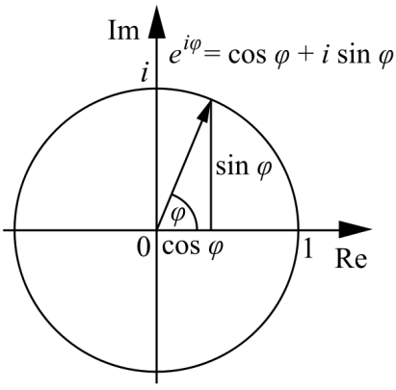

- A complex number can be written in the form of $z=x+iy$, where x and y are real numbers. The real part is x and the imaginary part is y.

- Complex numbers allow one to solve equations that have no real solution. For example, the solution to the equation ${\left(x+2\right)}^{2}=-16$ is $x=-2±4i.$ Here, realize that $i^{2}=-1.$

- Complex numbers can also be written in polar coordinates as $z={re}^{iφ}$, where r is the magnitude and $φ$ the phase. The magnitude is $r=\left|z\right|=\sqrt{x^{2}+y^{2}}$. Clearly the magnitude of $f\left(φ\right)=e^{iφ}$ is unity (i.e., = 1) for all values of the phase.

The plot of $Re[f\left(φ\right)]$ is a cosine wave, while that of $Im[f\left(φ\right)]$ is a sine wave. The two waves are π/2 out of phase with each other:

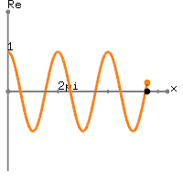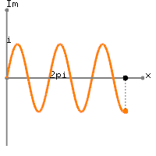
1.2 Plane Waves.

1.3 Fourier Series.

Any periodic function in one dimension such that

$$V\left(x\right)=V(x±a)$$

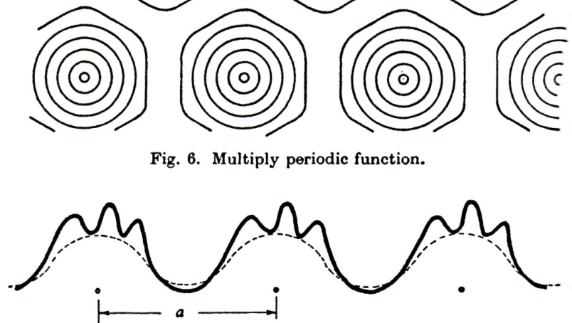

can be represented as a Fourier series (a linear combination of simple waves):

$$V\left(x\right)=\sum_{n=-∞}^{∞}{V_{n}e^{i(\frac{2πnx}{a})}},$$

where the wavelength of each simple wave is just a/n.
The Fourier coefficients V_{n} may be found by multiplying V(x) through by $e^{-i(\frac{2πmx}{a})}$ and integrating over the spatial period a:

$$\int_{0}^{a}{e^{-i(\frac{2πmx}{a})}V\left(x\right)dx}=\int_{0}^{a}{e^{-i(\frac{2πmx}{a})}V_{n}}e^{i(\frac{2πnx}{a})}dx$$

$$=V_{n}\int_{0}^{a}{e^{i[\frac{2π\left(n-m\right)x}{a}]}}dx$$
$$=V_{n}aδ_{m,n}$$

where $δ_{m,n}$ (Kronecker’s delta) is 1 if n = m and 0 otherwise. The Fourier coefficients are thus the overlap integrals of V(x) with each complex exponential component:

$$V_{n}=\frac{1}{a}\int_{0}^{a}{{V\left(x\right)e}^{-i(\frac{2πnx}{a})}dx}$$

The condition $\sum_{n}{{\left|V_{n}\right|}^{2}=1}$ is required to ensure normalization. If $V_{n}=1$, the function V(x) is identical to a cosine wave of wavelength a/n. If $V_{n}=0$, the function V(x) contains no component with wavelength a/n.

1.4 The Reciprocal Lattice.

In a similar way, a periodic function in three dimensions $V\left(r\right)$ may be invariant under translation by a set of Bravais lattice vectors R:

$$V\left(r\right)=V(r+R)$$

where V represents some periodic property of the lattice (e.g., electron density) and R takes the form

$R=n_{1}a_{1}+n_{2}a_{2}+n_{3}a_{3}$.

Here, {$n_{i}\}$ are integers and {$a_{i}$} are primitive lattice vectors.

Now we introduce a set of primitive reciprocal lattice vectors {$b_{i}$} that satisfy the following condition:

$$a_{i}⋅b_{j}=2πδ_{i,j} i=1, 2, 3, j=1, 2, 3.$$

where $δ_{i,j}$ is the Kronecker delta, which is equal to one when i = j and zero when i ≠ j.

Explicit formulas for the primitive reciprocal lattice vectors are given by the expressions

$$b_{1}=2π\frac{a_{2}×a_{3}}{a_{1}⋅{(a}_{2}{×a}_{3})}$$

$$b_{2}=2π\frac{a_{3}×a_{1}}{a_{1}⋅{(a}_{2}{×a}_{3})}$$

$$b_{3}=2π\frac{a_{1}×a_{2}}{a_{1}⋅(a_{2}{×a}_{3})}$$

Note that the reciprocal vectors are defined with reference to a particular Bravais lattice, often called the direct or real lattice.

- When i ≠ j, $a_{i}⋅b_{j}=0$ because the cross product of two vectors is normal to both.
- It follows that $a_{i}⋅b_{j}=2π$ for i = j since $a_{1}⋅{(a}_{2}{×a}_{3})=a_{2}⋅{(a}_{3}{×a}_{1})=a_{3}⋅{(a}_{1}{×a}_{2})$.

A general reciprocal lattice vector K is then

$K=hb_{1}+kb_{2}+lb_{3}$.

Here, {$h,k,l\}$ are integers and {$b_{i}$} are primitive vectors of the reciprocal lattice.

The Fourier expansion of the lattice potential is

$$V\left(r\right)=\sum_{K}{V_{K}e^{iK⋅r}}$$

This function is periodic in the direct lattice, because

$$V\left(r+R\right)=\sum_{K}{V_{K}e^{iK⋅(r+R)}=}\sum_{K}{V_{K}e^{iK⋅r}e^{i2π({hn}_{1}+{kn}_{2}+ln_{3})}}$$

and since {$n_{i}\}$ and {$h,k,l\}$ are integers,

$e^{i2π({hn}_{1}+{kn}_{2}+ln_{3})}=1$.

So,

$$V\left(r+R\right)=\sum_{K}{V_{K}e^{iK⋅(r+R)}=}\sum_{K}{V_{K}e^{iK⋅r}×1}=V(r)$$

The reciprocal lattice is thus the set of wave vectors K satisfying

$$e^{iK⋅R}=1$$

Two important points:

- The reciprocal lattice is itself a Bravais lattice.
- The reciprocal of the reciprocal lattice is the original direct lattice.

1.4.2. Important Examples

The simple cubic Bravais lattice with cubic primitive cell of side a has primitive lattice vectors

$a_{1}=a\hat{x}$, $a_{2}=a\hat{y}$, $a_{3}=a\hat{z}$

Its reciprocal lattice is another simple cubic lattice with cubic primitive cell of side $2π/a$:

$$b_{1}=2π\frac{a_{2}×a_{3}}{a_{1}⋅{(a}_{2}{×a}_{3})}=2π\frac{a^{2}\hat{x}}{a^{3}}=\frac{2π}{a}\hat{x}$$
Similarly, $b_{2}=\frac{2π}{a}\hat{y} and b_{3}=\frac{2π}{a}\hat{z}$

*Note that the reciprocal lattice vectors are parallel to the respective direct lattice vectors in this case.

The face-centered cubic Bravais lattice with conventional cubic cell of side a has primitive lattice vectors

$a_{1}=\frac{a}{2}(\hat{y}+\hat{z})$, $a_{2}=\frac{a}{2}(\hat{z}+\hat{x})$, $a_{3}=\frac{a}{2}(\hat{x}+\hat{y})$

and the body-centered cubic Bravais lattice with conventional cubic cell of side a has primitive lattice vectors

$a_{1}=\frac{a}{2}(\hat{y}+\hat{z}-\hat{x})$, $a_{2}=\frac{a}{2}(\hat{z}+\hat{x}-\hat{y})$, $a_{3}=\frac{a}{2}(\hat{x}+\hat{y}-\hat{z})$.

The reciprocal lattice for FCC is a body-centered cubic lattice with conventional cubic cell of side $4π/a$:

$$b_{1}=2π\frac{a_{2}×a_{3}}{a_{1}⋅{(a}_{2}{×a}_{3})}=2π\frac{\frac{a}{2}\left(\hat{z}+\hat{x}\right)×\frac{a}{2}\left(\hat{x}+\hat{y}\right)}{\frac{a}{2}\left(\hat{y}+\hat{z}\right)⋅\left[\frac{a}{2}\left(\hat{z}+\hat{x}\right)×\frac{a}{2}\left(\hat{x}+\hat{y}\right)\right]}$$

$$=2π\frac{\frac{a^{2}}{4}(\hat{z}×\hat{x}+\hat{z}×\hat{y}+\hat{x}×\hat{x}+\hat{x}×\hat{y})}{\frac{a^{3}}{8}\left(\hat{y}+\hat{z}\right)⋅[\left(\hat{z}×\hat{x}+\hat{z}×\hat{y}+\hat{x}×\hat{x}+\hat{x}×\hat{y}\right)]}=\frac{4π}{a}\frac{(\hat{y}-\hat{x}+\hat{z})}{\left(\hat{y}+\hat{z}\right)⋅[\hat{y}-\hat{x}+\hat{z}]}=\frac{4π}{a}\frac{(\hat{y}+\hat{z}-\hat{x})}{2}$$

Similarly, $b_{2}=\frac{4π}{a}\frac{(\hat{z}+\hat{x}-\hat{y})}{2} and b_{3}=\frac{4π}{a}\frac{(\hat{x}+\hat{y}-\hat{z})}{2}$

The reciprocal lattice for BCC is (of course) an FCC lattice with conventional cubic cell of side $4π/a$:

$$b_{1}=2π\frac{a_{2}×a_{3}}{a_{1}⋅{(a}_{2}{×a}_{3})}=2π\frac{\frac{a}{2}(\hat{z}+\hat{x}-\hat{y})×\frac{a}{2}(\hat{x}+\hat{y}-\hat{z})}{\frac{a}{2}(\hat{y}+\hat{z}-\hat{x})⋅\left[\frac{a}{2}(\hat{z}+\hat{x}-\hat{y})×\frac{a}{2}(\hat{x}+\hat{y}-\hat{z})\right]}$$

$$=\frac{4π}{a}\frac{(\hat{z}×\hat{x}+\hat{z}×\hat{y}+\hat{x}×\hat{y}-\hat{x}×\hat{z}-\hat{y}×\hat{x}+\hat{y}×\hat{z})}{(\hat{y}+\hat{z}-\hat{x})⋅[(\hat{z}×\hat{x}+\hat{z}×\hat{y}+\hat{x}×\hat{y}-\hat{x}×\hat{z}-\hat{y}×\hat{x}+\hat{y}×\hat{z})]}=\frac{4π}{a}\frac{(2\hat{y}+2\hat{z})}{(\hat{y}+\hat{z}-\hat{x})⋅(2\hat{y}+2\hat{z})}$$

$$=\frac{4π}{a}\frac{2(\hat{y}+\hat{z})}{4}=\frac{4π}{a}\frac{(\hat{y}+\hat{z})}{2}$$

Similarly, $b_{2}=\frac{4π}{a}\frac{(\hat{z}+\hat{x})}{2} and b_{3}=\frac{4π}{a}\frac{(\hat{x}+\hat{y})}{2}$.

The reciprocal lattice of an FCC lattice is a BCC lattice, and vice versa.

The reciprocal lattice of a simple hexagonal lattice with lattice constants c and a is another simple hexagonal lattice with lattice constants $2π/c$ and $4π/\sqrt{3}a$, rotated 30 degrees about the c-axis with respect to the direct lattice.

Important points:

- If the volume of the direct lattice primitive cell is v, the volume of the reciprocal lattice primitive cell is $(2π)^{3}/v$.

- The Wigner-Seitz primitive cell of the reciprocal lattice is called the first Brillouin zone (FBZ). The FBZ is important in the theory of electronic levels in a periodic potential.

FBZ of FCC lattice FBZ of BCC lattice
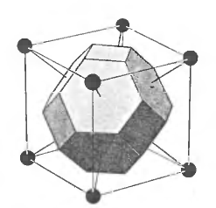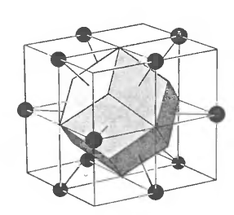

Lattice Planes.

For any set of direct lattice planes separated by a distance d, there are reciprocal lattice vectors normal to the planes, the shortest of which have a length of $2π/d$. Conversely, any reciprocal lattice vector K has a set of lattice planes normal to K and separated by a distance d, where $2π/d$ is the length of the shortest reciprocal lattice vector parallel to K.

Quick Proof:

Consider a set of lattice planes containing all the points of the three-dimensional Bravais lattice and separated by a distance d. Let $\hat{n}$ be a unit vector normal to the planes:

That $K=2π\hat{n}/d$ is a reciprocal lattice vector follows because a plane wave $e^{iK⋅r}$ is constant in planes perpendicular to wave vector K and separated by $λ=2π/K=d$. Note that one of the lattice planes must contain the Bravais lattice point $r=0$. This makes $e^{iK⋅r}=1$ for any point $r$ in any of the lattice planes (for example, $e^{i(2π\hat{n}/d)⋅d\hat{n}}=e^{i2π}=1$). Since the planes contain all Bravais lattice points R, K is indeed a reciprocal lattice vector. It must also be the shortest reciprocal lattice vector normal to the planes, since a shorter wave vector would give a plane wave with a wavelength longer than d and such a plane wave would not have the same value on all planes in the set.

Miller Indices.

One usually describes the orientation of a plane by giving the vector normal to that plane. Since we know that there are reciprocal lattice vectors normal to any set of lattice planes, it is natural to pick a reciprocal lattice vector to represent the normal. The Miller indices of lattice planes are the coordinates of the shortest reciprocal lattice vector normal to that plane, with respect to some set of primitive lattice vectors.

A plane with Miller indices h, k, l is normal to the reciprocal lattice vector $K=hb_{1}+kb_{2}+lb_{3}$.

In other words, the Miller indices are the coordinates of the normal in a system defined by the reciprocal lattice, rather than the direct lattice. They are directions in the reciprocal lattice.

*This definition is equivalent to our earlier definition involving inverse intercepts in the direct lattice.

